Case Study on Clubfoot

 | Shahjalal University of Science and Technology, Sylhet
 | Department of Genetic Engineering and Biotechnology

Case Number: | Date:

Dear sir / madam,
We are writing to request your participation in a medical case study on club foot disease. The purpose of this study is to better understand the treatment and outcomes of club foot in children and to share this information with the medical community.
As a participant in this study, you will be asked to undergo a series of medical evaluations, including physical examinations, imaging tests, and possibly surgery. You will also be asked to provide information about your medical history and any previous treatment you have received for club foot.
Your participation in this study is voluntary, and you may choose to opt out at any time. If you decide to participate, you will be asked to sign a consent form. You are also welcome to bring a family member or friend with you to the evaluations and to ask any questions you may have before deciding whether to participate.
We understand that participating in this study may be inconvenient for you and your family, and we deeply appreciate your willingness to help us improve the treatment of club foot.
Thank you for considering this opportunity to contribute to medical research.
We take the privacy and security of your personal and medical information very seriously. All information collected as part of this study will be kept confidential and will be stored securely in accordance with relevant laws and regulations. Only the research team will have access to your personal and medical information, and we will take all necessary precautions to protect it. No identifying information about you will be shared with any third parties without your explicit written consent.
Sincerely,
The team members and all authority

Please sign if you decided to give us your consent.

_________________________
Signature of Patient/Guardian

Patient Information:
Name |  | Age
Phone |  | Sex
Birth order |  | Blood Group
Height |  | Weight
Father’s name |  | Number of siblings
Mother’s name |  | Number of children
Address

Family History:
Family Members | Age | Does s/he have Clubfoot? | If yes, has s/he recovered?
Father |  | ☐ Yes ☐ No | ☐ Yes ☐ No
Mother |  | ☐ Yes ☐ No | ☐ Yes ☐ No
Siblings |  | ☐ Yes ☐ No | ☐ Yes ☐ No
Children |  | ☐ Yes ☐ No | ☐ Yes ☐ No
Grandfather(p) |  | ☐ Yes ☐ No | ☐ Yes ☐ No
Grandmother(p) |  | ☐ Yes ☐ No | ☐ Yes ☐ No
Grandfather(m) |  | ☐ Yes ☐ No | ☐ Yes ☐ No
Grandmother(m) |  | ☐ Yes ☐ No | ☐ Yes ☐ No
Additional details

Prenatal diagnosis by ultrasound |  | ☐ Yes ☐ No
Any plan ahead for treatment? |  | ☐ Yes ☐ No
Diagnosed in which week?
Additional details

Affected Leg | ☐ Left leg ☐ Right leg

Type of Clubfoot:
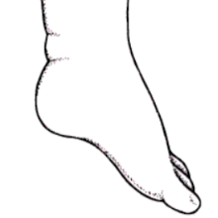 | 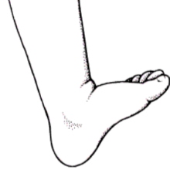 | 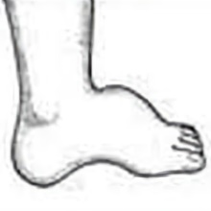
☐ Equinus | ☐ Calcaneus | ☐ Cavus
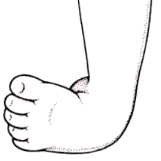 | 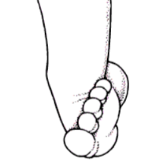 | 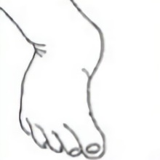
☐ Varus | ☐ Valgus | ☐ Adductus

Treatment:
Did you take any treatment? | ☐ Yes ☐ No
Treatment duration
Start date
End date
In which institute?
Which method/s they used?
Medical expenses

Post-treatment status (medications/exercises/problems):

Other Diseases:

Additional information:

Surveyor
Name
Reg No. | 20204310

